Map Atlas

Purpose: The objective of this application is to bring all the radio stations at one place. And, it allows user to add their favorite stations across worldwide.

Description:

On loading of an application, users can see all the available stations at users

Location. And, also the screen has Volume controller, Play and Pause Button, Favorites Button.

Volume Controller helps user to increase and reduce the volume.

Play and Pause buttons helps user to pause and re-play station.

Image1: Initial map view

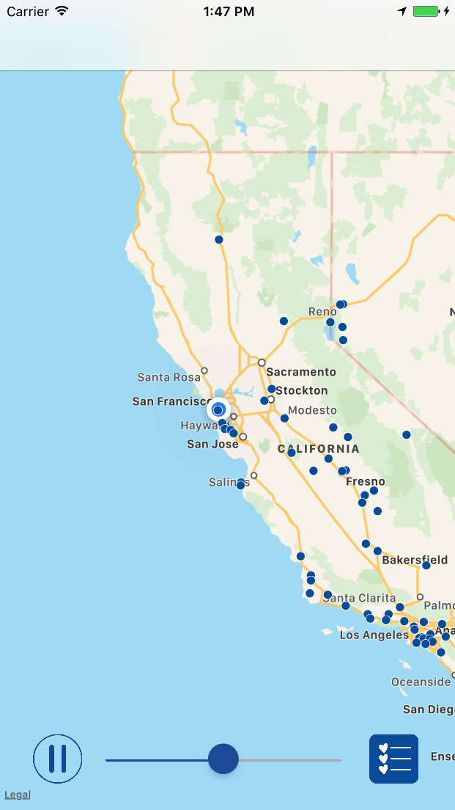

Click on any of the annotation that has displayed on the map. It starts playing radio station and open annotation view.

Annotation view has station name, location of the station, left accessory view, right accessory view.

Image 2: Annotation View

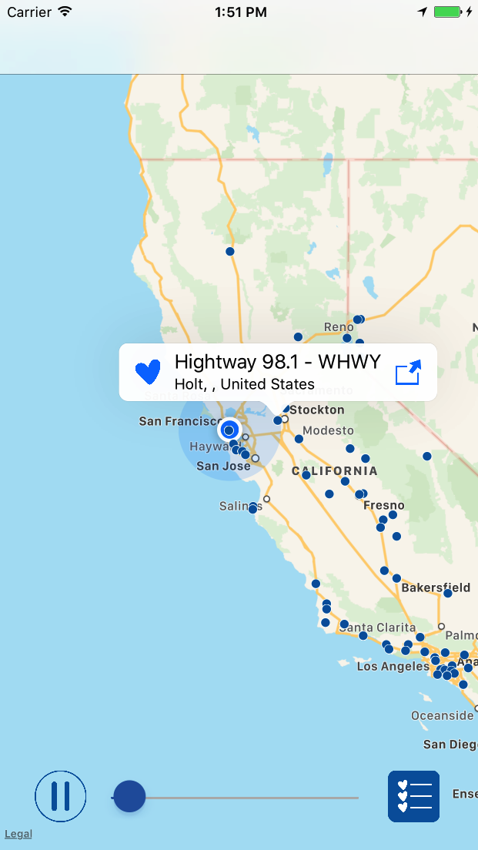

When user clicks on the left accessory view, station details saves into favorites by using Core data and hides favorite button. When user deletes it from the favorites, the left accessory view appears only after re-launching the app.

Image 3: Hidden favorite button after it has been added to favorites

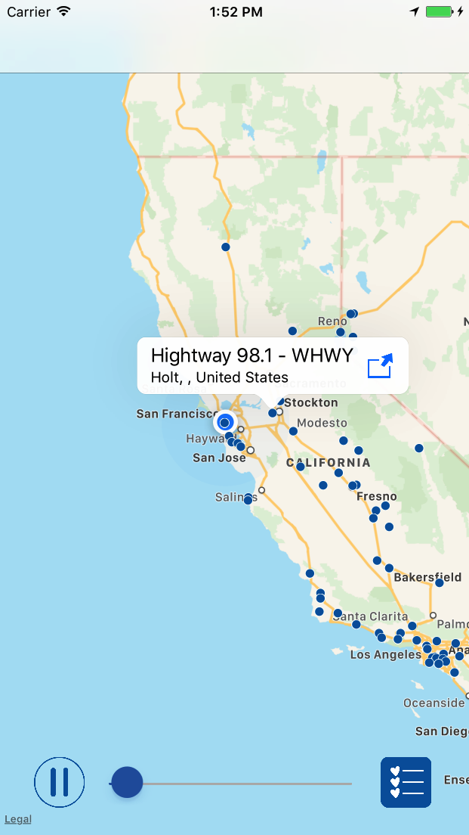

Click on the right accessory view, it navigates the user to the website of the actual streaming. And, the user can return to accessory view through segue.



There is a Favorites button on the bottom of the map next to volume controller where it displays all the list of favorite stations that are selected by the user.

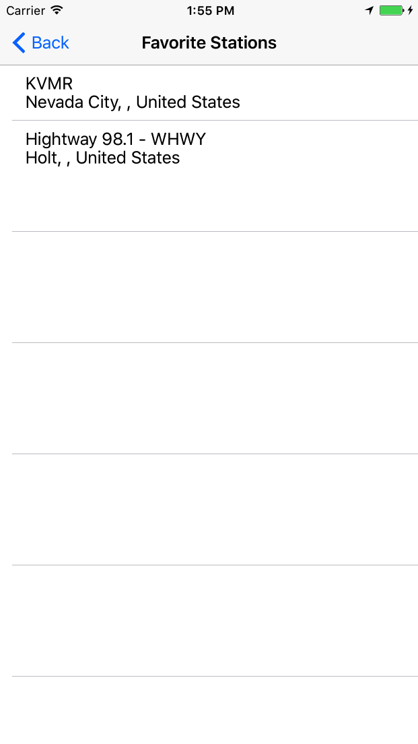

Slide on any of the table item, system displays delete button to delete the station from favorites.

